Activity No 1.
Title of the Event | Marketing Club Event “LOGONOVA” | 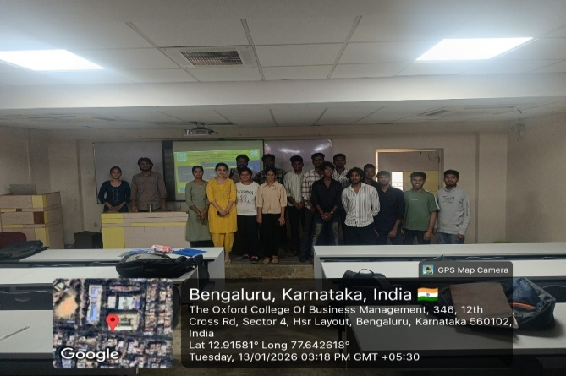
Day and Date | 13 January 2026
Venue (With all details ) | Room No- 309
In collaboration with ( if any)
Details of Resource Person With Designation | Dr.Veto Dey | 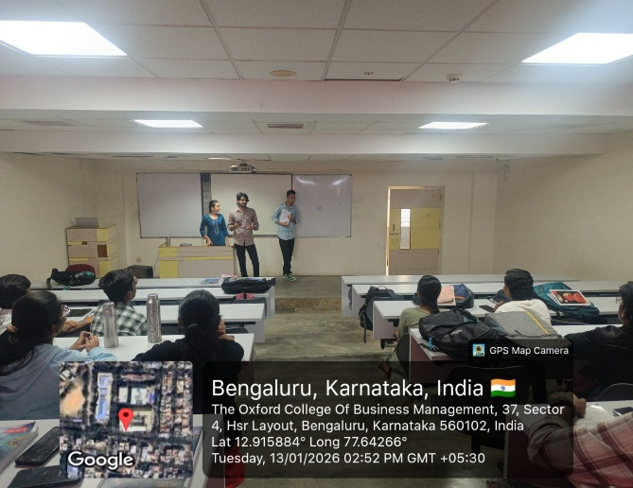
Organizing Department/Coordinators | Business Management , Dr.Veto Dey
Course and semester | MBA I Sem
No of Students & Faculty Participants | 43

Coordinator HoD Vice-Principal Principal

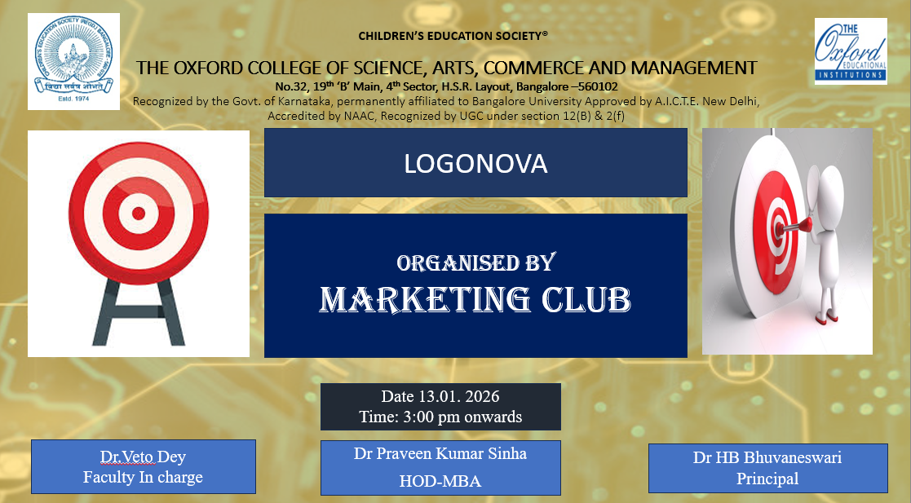

Introduction
In the contemporary marketing landscape, visual identity plays a crucial role in building strong brand recognition and recall. To help students understand the importance of logo design and brand symbolism, the Marketing Club of the Department of MBA organized an engaging and creative activity titled “Logonova”. The activity aimed to enhance students’ creativity, branding knowledge, and practical application of marketing concepts through experiential learning.
Description of the Activity
The Logonova activity was conducted on 13 January 2026 for MBA students during the Marketing Club hour. Students were divided into teams and were assigned the task of designing an innovative logo for a hypothetical or real brand. Each team conceptualized the brand name, target audience, and core values before designing the logo. Students also presented the rationale behind their logo design, explaining color choices, symbols, typography, and brand message. The activity encouraged brainstorming, teamwork, and application of branding theories in a practical and interactive manner.
Outcome of the Activity
The activity helped students gain a clear understanding of the role of logos in brand identity and positioning. Students demonstrated improved creativity, strategic thinking, and presentation skills. They were able to relate theoretical branding concepts to real-world marketing practices. Active participation and enthusiastic involvement reflected enhanced interest in branding and visual marketing strategies. The activity also fostered collaboration and communication among students.
Conclusion
The Logonova activity proved to be an effective and engaging learning initiative by the Marketing Club. It successfully bridged the gap between theory and practice by allowing students to experience the process of brand identity creation firsthand. Such creative activities contribute to deeper learning, better concept retention, and overall skill development. The Department of MBA will continue to organize similar innovative and student-centric activities to enrich the learning experience and nurture future marketing professionals.

